
QUALITY ALERT

Customer: United Date: Mar 7, 2025
Die: 15141 Colour: ALL
Type of Complaint: United REJECTED

Q.A # Q.I.R # CUSTOMER NCR #

Description: United REJECTED due to glazing leg moving, leave gap on/off when inserting glass stop.

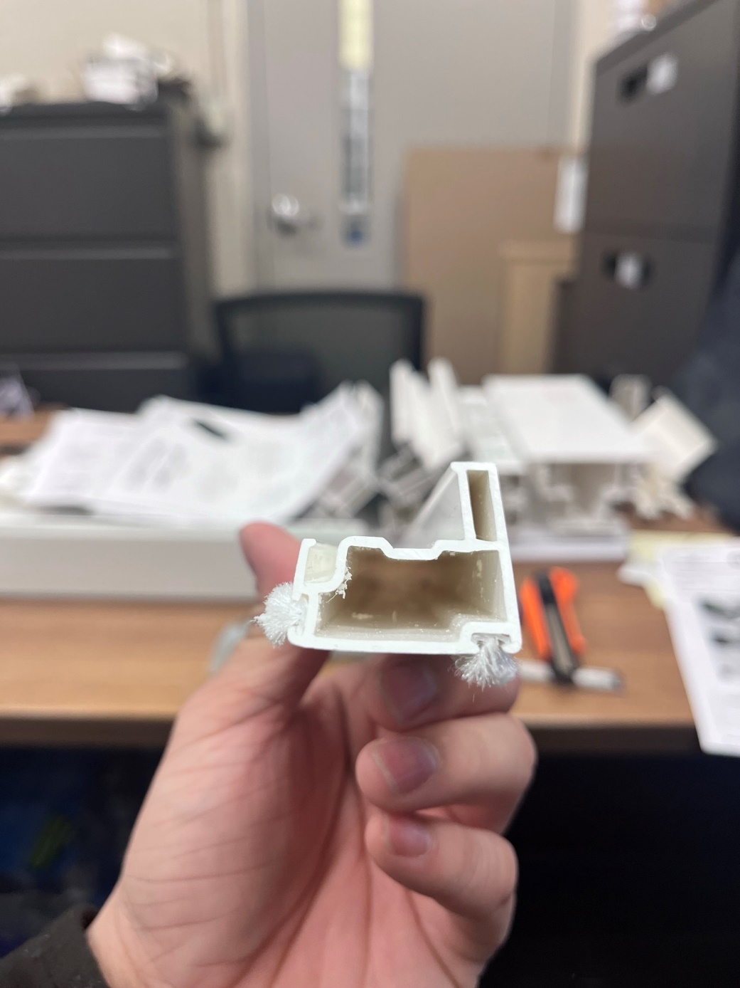

THIS LEG MOVING

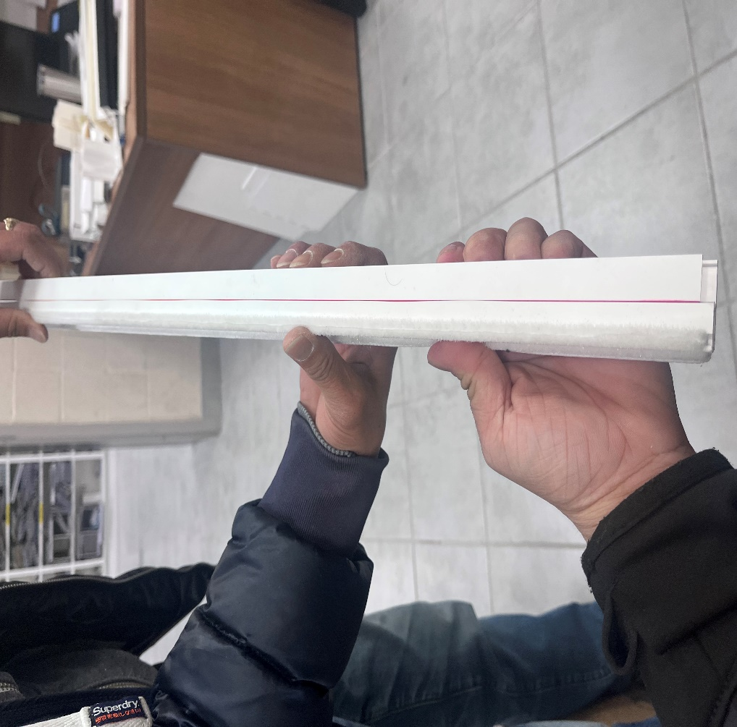

PLEASE MAKE SURE GLAZING LEG IS NOT MOVING
BY SIGNING BELOW, YOU ACKNOWLEDGE THE PROBLEM ABOVE AND AGREE TO MONITOR THIS ISSUE IN FUTURE PRODUCTION RUNS.
DAY SHIFT |  | AFTERNOON SHIFT |  | NIGHT SHIFT
NAME | SIGNATURE | NAME | SIGNATURE | NAME | SIGNATURE

